**PROGRAM-9(A);**

**a) Write a program to traverse a graph using BFS method**.

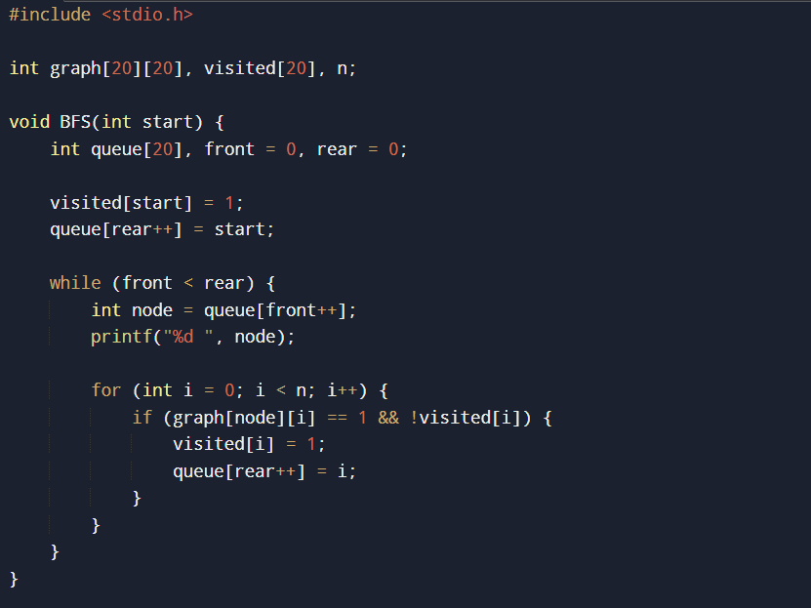





**PROGRAM-9(B):**

**b) Write a program to check whether given graph is connected or not using DFS method.**

